***Alec Fredricksson***

***Shannon Lai***

***Simond Liu***

***Wilson Lam***

Instructor: Dr. Xiaochun Li

TA: Injoo Hwang

03/21/2014

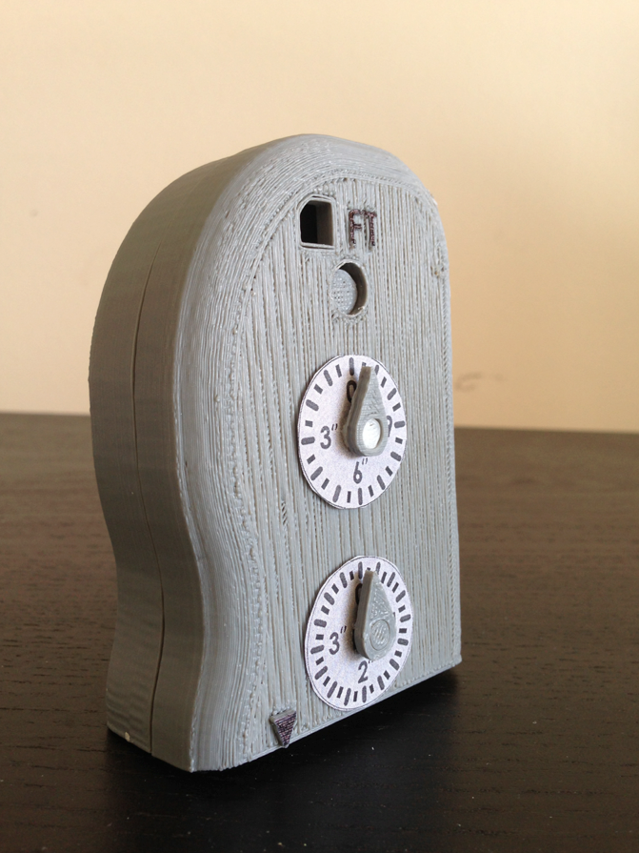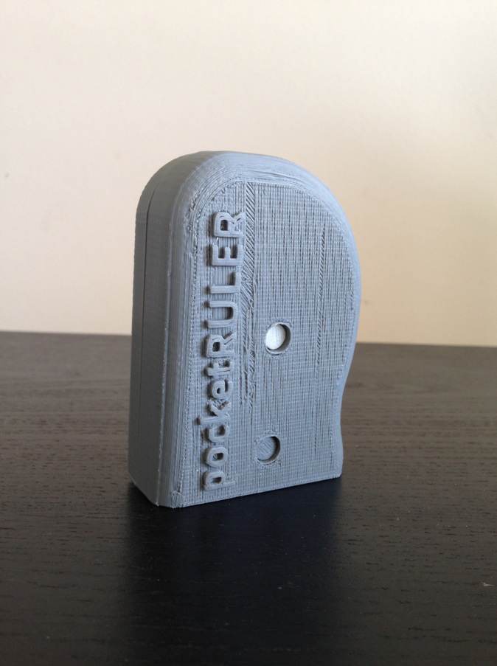

Figure 1: (Left) Front and (Right) Back of PocketRULER.

Stratasystems

pocketRULER

***MAE 298 – Rapid-Prototyping and Manufacturing***

**Table of Contents**

1 List of Figures 2

2 List of Tables 2

3 Background/Motivation 3

4 Idea Generation and Iteration with Team Work Ethics and Brainstorming 4

4.1 Idea Generation, Iteration, and Brainstorming of Initial Design 4

5 Functionality/Creativity 6

6 Design Cycle 1 and Design Cycle 2 7

7 Final Design and Fabrication Result Analysis 9

7.1 Final Design 9

7.2 Geneva Gear Analysis for the Final Product 10

7.3 Wheel FEA 12

8 Project Improvement 14

9 Conclusions 15

10 Acknowledgements 16

11 References 17

12 Appendices 18

12.1 Initial Designs 18

12.1.1 Design 1 19

12.1.2 Design 2 19

12.2.1 Design 3 21

12.2.2 Design 4 22

12.2.3 Design 5 23

12.2.4 Design 6 24

12.2.5 Design 7 25

12.2.6 Design 8 26

12.2.7 Design 9 27

# List of Figures

Figure 1: (Left) Front and (Right) Back of PocketRULER. i

Figure 2. Use of a Surveyor's Wheel 3

Figure 3. Initial Drawing of pocketRULER 3

Figure 4. The pocketRULER 6

Figure 5. Cycle 1 Print Results 7

Figure 6. Cycle 2 Print Results 8

Figure 7: Overview of design cycles. 9

Figure 8: Final pocketRULER design with half of housing removed. 10

Figure 9: Geneva Gear schematic for calculation. 10

Figure 10: Geneva Gear governing equations. 11

Figure 11: This figure feature 3 different positions for the tensile test. (A) Up-Right (B) Face-Up and (C) Edge-Up position [1]. 12

Figure 12: Wheel part FEA. (A) Depicts the Up-Right printing position (B) Part FEA is performed on and (C) FEA results. 13

# List of Tables

Table 1: List of Stratasystem’s initial designs. 4

Table 2: Design Comparison Chart. 5

Table 3: Geneva Gear calculation results (units in inches). 11

Table 4: The four highest scoring design from the Comparison Chart. 18

# Background/Motivation

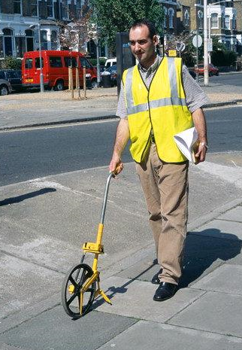From engineers, carpenters, architects, to the do-it-yourself home hobbyist, distance measuring devices are extremely vital to achieving successful projects. Devices such as micrometers or calipers are used to measure small distances with extreme accuracy, while rulers or tape measures are used to measure larger distances. However, the major pitfall of these devices is its limitation to measuring only linear dimensions. There is no easy method to measure curves or arcs directly using these tools. The most common method of measuring curves or complex geometries is by using a string to outline the curve or shape, and then measuring the length of the string used by a ruler or tape measure. Unfortunately, this method is time consuming, requires a method to hold the string in place, and is not convenient.

Figure 2. Use of a Surveyor's Wheel

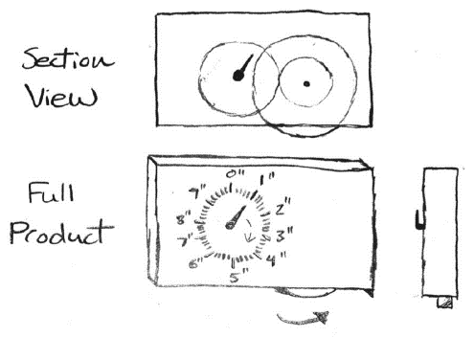The lack of a convenient curve measuring device in today’s market provided the motivation for developing the pocketRULER, a compact measuring device that not only had the capability of measuring straight lines, but also be able to measure curves and complex geometries for longer distances (at least a foot). The initial concept was inspired by a tooled called a surveyor’s wheel ( Figure 2), which is used to measure on the scale of hundreds of feet. This devices uses a wheel that rolls along a surface and by counting the revolutions of the wheel, the distance travelled can be determined. The concept of the pocketRULER (Figure 3) borrows this idea of a rolling-wheel along a surface to measuring distance. However, in order to measure longer distances while in a smaller and more compact device, a gear train was implemented to compactly keep track of distance measured.

Figure 3. Initial Drawing of pocketRULER

# Idea Generation and Iteration with Team Work Ethics and Brainstorming

Stratasystems work policy involves team members collaborating during the weekend and discussing new designs weekly. From the detail of idea generation to the individual iteration of each design, our work entails group meetings to discuss changes. Each change to the overall design requires approval and analysis from every member of the group.

## Idea Generation, Iteration, and Brainstorming of Initial Design

The initial process for generating the ideas was listing out several possible designs that could be manufactured using the MakerBot (a type of FDM). The ideas that were formulated and discussed by the group are as follow:

Table 1: List of Stratasystem’s initial designs.

|  |  |
| --- | --- |
| **Design** | **Name of Design** |
| **1** | **Pocket Ruler** |
| **2** | Adjustable Smartphone Stand |
| **3** | Recharging Phone Stand |
| **4** | **Retractable Earphone Cord** |
| **5** | Toothpaste Squeezer |
| **6** | **Wallet (with quick access to cards)** |
| **7** | Pencil Pen Integration Design |
| **8** | **Horizontal Motion 6 Bar Linkage Pencil Holder** |
| **9** | Gear Design Robotic Hand |

Table 2: Design Comparison Chart.

|  |  |  |  |  |  |  |  |  |  |  |
| --- | --- | --- | --- | --- | --- | --- | --- | --- | --- | --- |
|  |  | **Design** |  |  |  |  |  |  |  |  |
| **Design** | **Weight** | **1** | **2** | **3** | **4** | **5** | **6** | **7** | **8** | **9** |
| **Creativity** | 21% | 1.9 | 0.9 | 0.9 | 1.7 | 0.9 | 1.7 | 1.1 | 1.5 | 0.9 |
| **Functionality** | 29% | 2.6 | 2.3 | 1.7 | 2.3 | 1.1 | 2.3 | 2.3 | 2.0 | 1.7 |
| **Complexity** | 29% | 2.3 | 1.1 | 1.7 | 2.3 | 1.1 | 2.3 | 1.7 | 2.6 | 2.3 |
| **Aesthetics** | 21% | 1.7 | 1.7 | 0.9 | 1.7 | 0.9 | 1.7 | 1.3 | 1.9 | 0.9 |
| **Total:** | 100% | ***8.5*** | 6.0 | 5.1 | ***8.0*** | 4.0 | ***8.0*** | 6.4 | ***8.0*** | 5.7 |

From Table 2, an attempt to narrow down the various group designs was done by using a comparison chart. The comparison chart is constructed by each member evaluating the following categories: creativity, functionality, complexity, and aesthetics from 1 to 10 (10 being the highest). To normalize the value, the total is divided by 40. The resulting scale is now between 1 and 10. The value is then multiplied by the weight of each categories in the second column. This weight comes from the results of the class discussion by a majority vote for scoring the product design.

* Creativity (15%)
* Functionality (20%)
* Complexity/Difficulty (20%)
* Aesthetics (15%)
* Team work and presentation (20%)
* Final report (10%)

The “team work and presentation” along with “final report” does not affect the overall product design and were remove from the categories resulting in the new percentage weight. This weight is obtain by using the following methods.

* 15%/70% for creativity 🡪 21%
* 20%/70% for functionality 🡪 29%
* 20%/70% for creativity 🡪 29%
* 15%/70% for creativity 🡪 21%

With this new scoring guideline, narrowing down the initial design was simplified. The results are shown in bold in Table 2. For the results of all the initial design refer to the Appendix.

# Functionality/Creativity

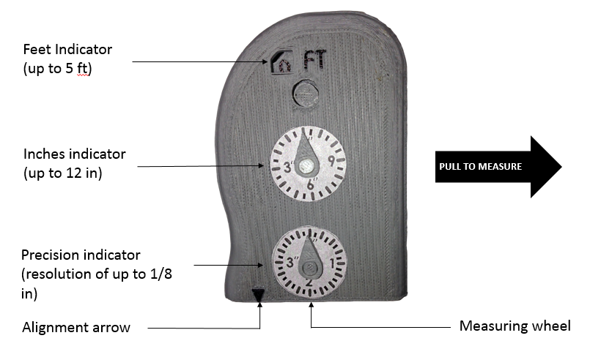

The compact pocketRULER is about 3.9 inches tall and 1.5 inches thick, and provides an ergonomic housing for a comfortable grip during usage, as seen in Figure 4. To use the pocketRULER, simply place the measuring wheel, located at the bottom of the device, on a surface and line up the starting position of the measurement with the alignment arrow. Pull it along to the surface to measure the distance and stop when the alignment arrow meets the intended end of the measurement. The measuring wheel is connected to a gear train inside the housing, so when the wheel rotates, the gear train inside the housing also moves. By implementing a gear reduction gear train, the pocketRULER can measure up to 5 feet in a compact housing. Attached to each gear are indicators that display the measurements in different resolutions. The feet indicator displays the feet traveled, up to five feet. The inches indicator displays the inches measured and the precision indicator displays a more accurate inch reading with resolution up to an eighth of an inch. To read the total measurement combine the displayed value on the feet and inches indicator, and if necessary look at the precision indicator.

Figure 4. The pocketRULER

The only existing tool in the current market that allows for curve measurements are thin flexible rulers. They are hard to use and not compact. The length of the ruler required would need to be as long as the length of the distance needed to be measure, hence making this tool very impractical. The pocketRULER is the first of its kind; it is a compact device that allows for measurement of lines, curves, and complex geometries. It has the capability of measuring up to 5 feet, with only a measuring error of 1%, due to the inaccuracies of the rapid prototyping machine used. The pocketRULER has the capability of being even smaller and more accurate, with better part tolerances achieved using a different manufacturing process than fused deposition modeling.

# Design Cycle 1 and Design Cycle 2

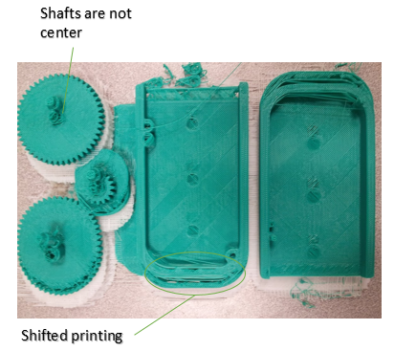The initial design of the product consisted of three gears and a housing. With the use of compound gear trains, measurements of up 4 feet could be obtained. In this design, three dial indicators displayed the feet, inches, and precision inches. Because of the large size of this initial design, printing the parts took up the majority of MakerBot’s working surface. The result of the first cycle print was a failure; it seemed like the entire print head shifted mid-print and caused the parts to have incorrect geometries (Figure 5). The shafts of the gears are far from center, and the housing was also misaligned. Although, this first design was reprinted, the same outcome was the same, with the parts having the same error. Thus, it was suspected that the MakerBot could not handle printing several parts that took up most of the working area because the software either had difficulties process planning many parts, or there was not enough room on the working surface for the MakerBot to build a proper purge wall.

Figure 5. Cycle 1 Print Results

The first cycle print did not provide any functional parts, and no assembly or proof of concept was achieved. However, the lessons learned were invaluable. It was realized that not only was it risky to print several large parts on the MakerBot, but the machine had higher than expected tolerances and had difficulty creating accurate circular components. Furthermore, the MakerBot was capable of printing the small gear teeth, a component that was initially of high concern that the machine could not fabricate. For the second design cycle, the main purpose was to ensure that a functional part would be produced and that it could be assembled for a proof of concept. Since, it was risky to reprint a similar design with many components and to avoid the same problems occurred in cycle 1, it was decided for cycle 2 that the gear that displayed the feet would be entirely removed from the design. Although, this designed only allowed for measurements of 1 foot, the size was substantially reduced, which decreased the printing time of 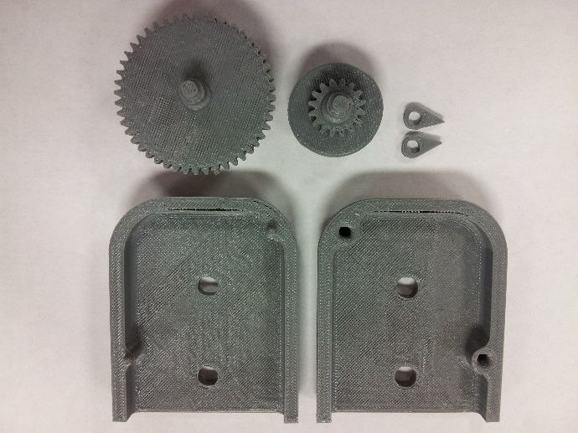the parts, and made it less error prone during the machine process planning and fabrication. The result of the print was satisfactory as seen in Figure 6. The parts came out well, and the gears printed better than expected and meshed consistently. The parts were capable of assembly, and the functionality was tested. In this design cycle, it was proved that the concept was feasible and had potential. Having been able to assemble the product, other tolerance issues were noticed which would be fixed in cycle 3. After proving the potential of the product, for the last and final design cycle, the aim was to increase the functionality of the product to measure more than a foot, while minimizing the size to decrease manufacturing time and potential risk of print errors.

Figure 6. Cycle 2 Print Results

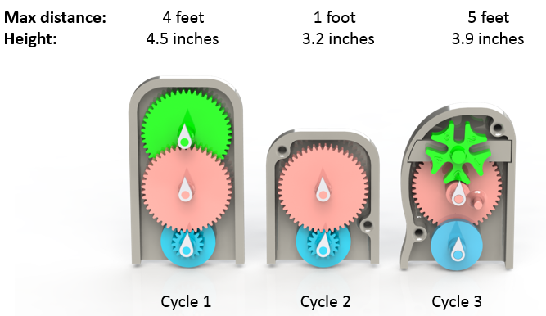

Figure 7: Overview of design cycles.

# Final Design and Fabrication Result Analysis

## Final Design

In the final design, the Geneva gear was incorporated to reduce the housing size and increase the overall measurement capabilities. The detail of the device is displayed in Figure 8.

In this final product, the Geneva gear was the main change in the design that gives the product the crucial improvement to increase measuring distance and reduce production time. The housing groove is also added to increase the general appearance of the part design.

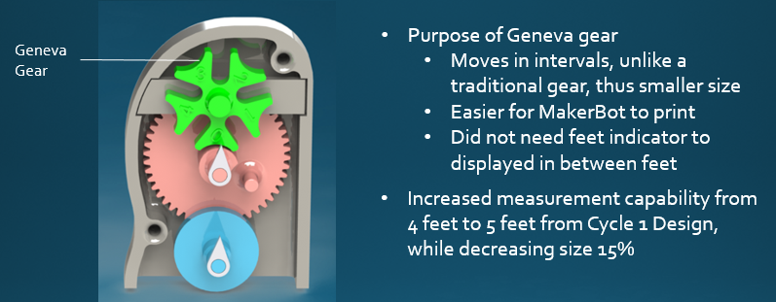

Figure : Final pocketRULER design with half of housing removed.

The final design in Figure 8 shows the lists of changes made to the final pocketRULER design. The green part is the driven Geneva gear that was added to the final design. The red gear is what drives the Geneva gear. To create this part, calculation were perform to determine the geometric properties for both the driving and driven Geneva gears.

## Geneva Gear Analysis for the Final Product

To create a working Geneva gear, research on the general equations to calculate the geometry of this type of gear were looked into. The results of the calculation are display below.

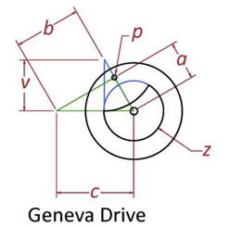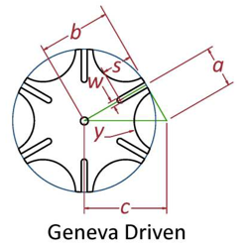

Figure : Geneva Gear schematic for calculation.

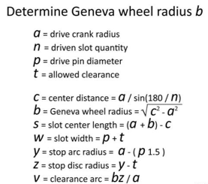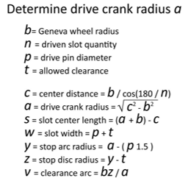

Figure : Geneva Gear governing equations.

Table : Geneva Gear calculation results (units in inches).

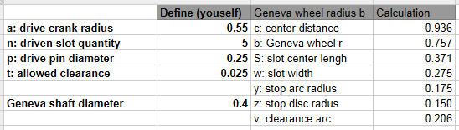

## Wheel FEA

In the final design fabrication finite element analysis were perform on the rolling wheel. The FEA is done on the wheel because the normal force of the ground creates a reaction force on the wheel were found to be the critical stress experienced throughout the whole part.

When testing FDM produced parts for the MakerBot, research data was first obtain for general FDM produced ABS parts. In a research journal written by Smith, ABS material were tested in a tensile test and the largest ultimate tensile strength were found to be along the face-up position. The research explains that orientation of FDM produced part will determine the structural strength of the part produced [1]. The measuring wheel in the pocketRULER is oriented in the up-right position. From the research, 23MPa is estimated to be the yield strength for this up-right position. (Note: The up-right position exhibit brittle like properties so both yield strength and ultimate tensile strength are about the same.)

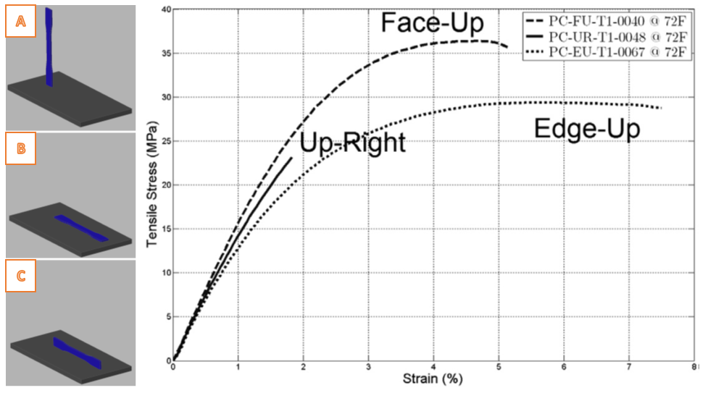

Figure : This figure feature 3 different positions for the tensile test. (A) Up-Right (B) Face-Up and (C) Edge-Up position [1].

The extrusion direction of the nozzle will also determine the material strength of the FDM wheel part. Recent research done by Smith and Dean, shows that repeatable measurements can be made for both ultimate tensile strength and elastic modulus of FDM manufactured parts. With the yield strength found, the FEA analysis for the MakerBot produced part can be analyzed.

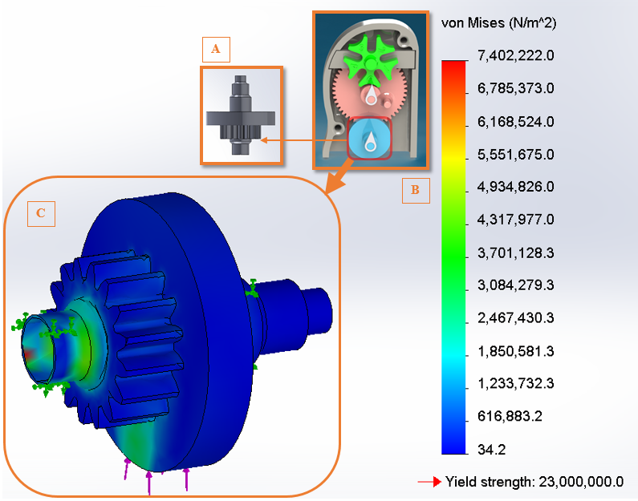

Figure : Wheel part FEA. (A) Depicts the Up-Right printing position (B) Part FEA is performed on and (C) FEA results.

From research data and FEA analysis the following were found:

* Average Human Arm-Hand Weight:
  + 3.35 kg (7.39lb) 🡪 33 N
* FEA Tested at:
  + 10.2 kg (22 lb) 🡪 100 N
* Maximum Load for this MakerBot part is around
  + 60 lb

The FDM part can handle up to 60lbs providing a reasonable safety factor. When compare to the weight of the human arm at least 8 times this load is needed before failure of the wheel shaft occurs. The wheel shaft is hollow out in the FEA analysis to provide better analysis results. The hollowing out of the part is done to closely imitate the honeycomb effect the MakerBot produces.

# Project Improvement

In regards to project improvement, the pocketRULER was designed to be as compact as possible but still be able to be fabricated using the given RP machine. The main factor limiting the design was accuracy of the RP machine to be able to print critical features accurately. Critical features, such as the gear teeth profiles and Geneva gear profiles, must be fabricated with a very tight tolerance to ensure the correct fit and meshing between the chosen gear train. In addition, in order to improve the resolution of the pocketRULER, a smaller diameter wheel must be printed to achieve a small circumference. A smaller diameter wheel would then require an even smaller wheel gear. With a more accurate RP machine and possibly using a more accurate process, the size of the pocketRULER can be reduced by more than 50%. Using a series of smaller gears (similar to a watch) a higher gear reduction ratio can be achieved allowing for more precision and resolution of the device as well as a reduction in size. Having a more compact and complex gear train has multiple effects on the improvement of the overall design. It allows for a more compact design as well as increased functionality, such as having the ability to measure a larger distance. More dials can also be incorporated to give us different units of measurements (SI or Imperial).

A reset mechanism can also be incorporated so the user does not have to manually calibrate the device after every use. The reset mechanism can be a mechanical mechanism as well as an electromechanical mechanism. Electronic instruments can be implemented in the housing to record certain gear rotations and keep track of the measurement in a more precise way with a “zero” function to reset the device without having to physically rotate the gears. Other minor improvements such as a guide rail or attachments to extend the reach of the device, for example, could also be incorporated into the design for more functionality and efficiency.

# Conclusions

The design intent of the pocketRULER was a device that is both handy or compact and able to measure curves or complex geometries that rulers or tape measures would have difficulty in measuring. The entire design process was an iterative process starting with the 4.5 inch height cycle 1 design. After fabrication of the cycle 1 design, the limitations of the RP machine were realized and a simplified cycle 2 design was achieved. Although cycle 2 provided a more compact design, it lacked the functionality from the first cycle design. With the use of a new gear mechanism (Geneva gear) a more compact design was achieved that also allowed for added functionality. The device can measure up to 5 feet with an accuracy within 1% (1/8 inch deviation per foot). Analysis was done using Finite Element Analysis (FEA) to predict the maximum load the wheel shaft can withstand since this area was the weakest point in the design. Analyzing different configurations, the maximum load was calculated to be approximately 60 lbs. With quite a few parts and complex components, the assembly process was very critical. Tight tolerances were needed to ensure proper meshing between the gear train as well as ensuring the correct fit between the gear shafts and housing. The use of form fitting contours and large radius fillets allowed for a comfortable ergonomic design that fits both left-handed and right-handed users. In terms of future improvements, plans for a smaller more compact overall design is a primary focus as well as more accuracy and a reset mechanism. The reset mechanism can be a digital reader that would require no manual calibration of the device and provide for a more accurate reading. Additional improvements could be the addition of attachments and add-ons to improve the overall functionality.

# Acknowledgements

We would like to thank Professor Xiaochun Li and Injoo Hwang for their guidance and support.

# References

|  |  |
| --- | --- |
| [1] | W. C. Smith and R. W. Dean, "Structural characteristics of fused deposition modeling polycarbonate material," Elsevier, 24 July 2013. [Online]. [Accessed 18 February 2014]. |

# Appendices

## Initial Designs

Table 4: The four highest scoring design from the Comparison Chart.

|  |  |
| --- | --- |
| Stratasystem’s Product Designs | Product Description |
| C:\Users\USER\Desktop\Picture3.png | Multipurpose pocketruler that is capable of measuring lines and curves. Use gears as was the initial thought process for this design. |
| C:\Users\USER\Desktop\6.PNG | Earphone design with a retractable spring that wind up all the wire of the earphone when not in use. |
| C:\Users\USER\Desktop\7.PNG | Wallet with spring loaded cards to access the different cards quickly. Also organize all the cards in order and separate them in the card holder. |
| C:\Users\USER\Desktop\5.PNG | Six bar linkage design pencil holder design for complexity over functionality. Serve mostly as an educational purpose. |

### Design 1

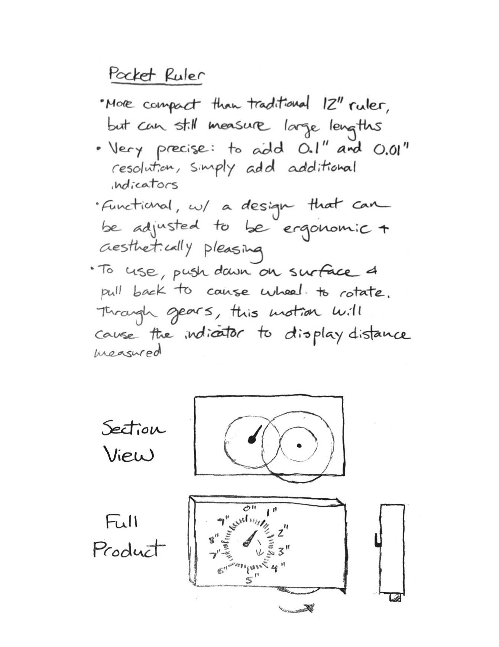

### Design 2

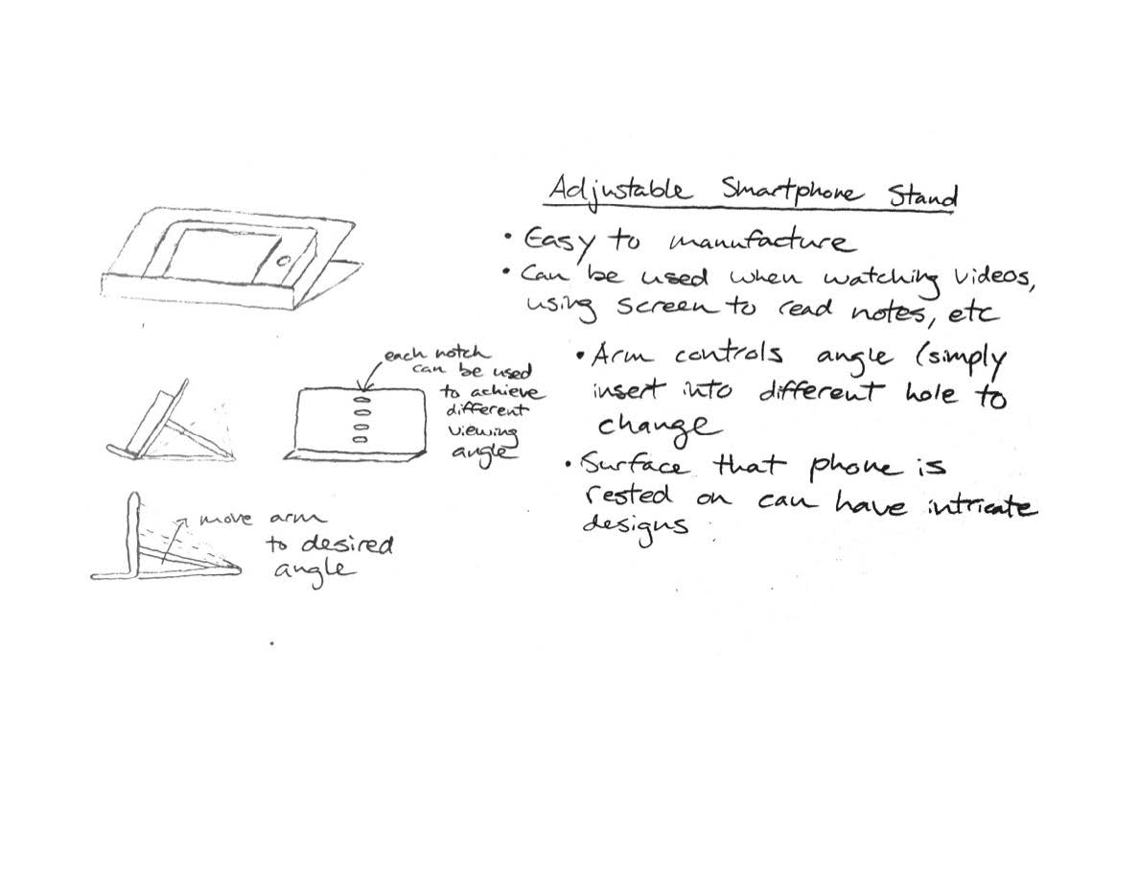

### Design 3

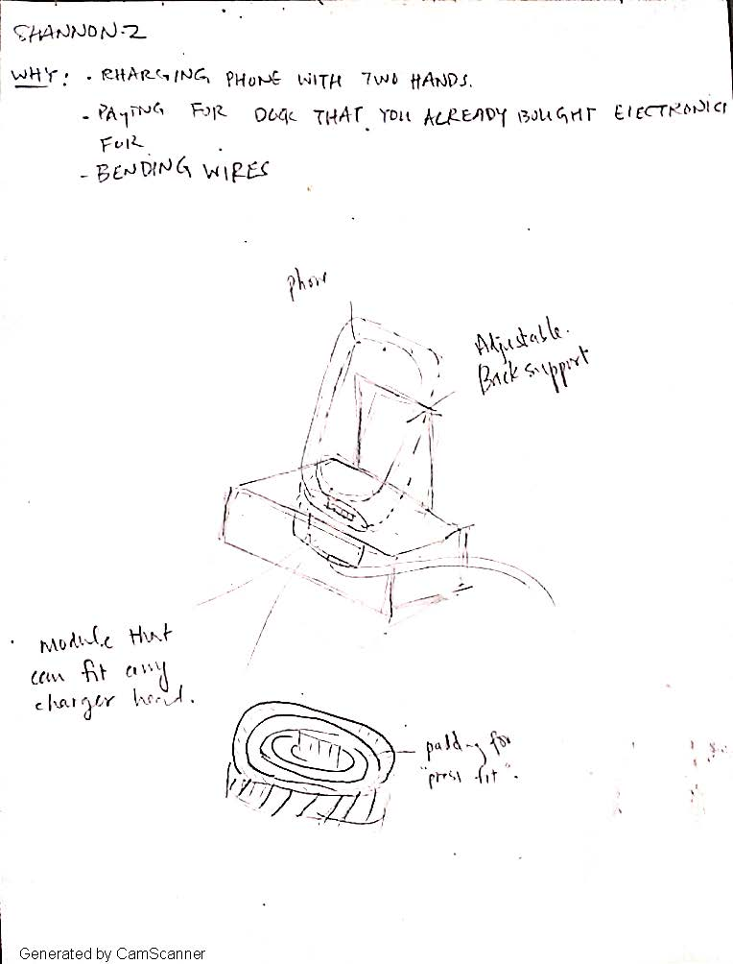

### Design 4

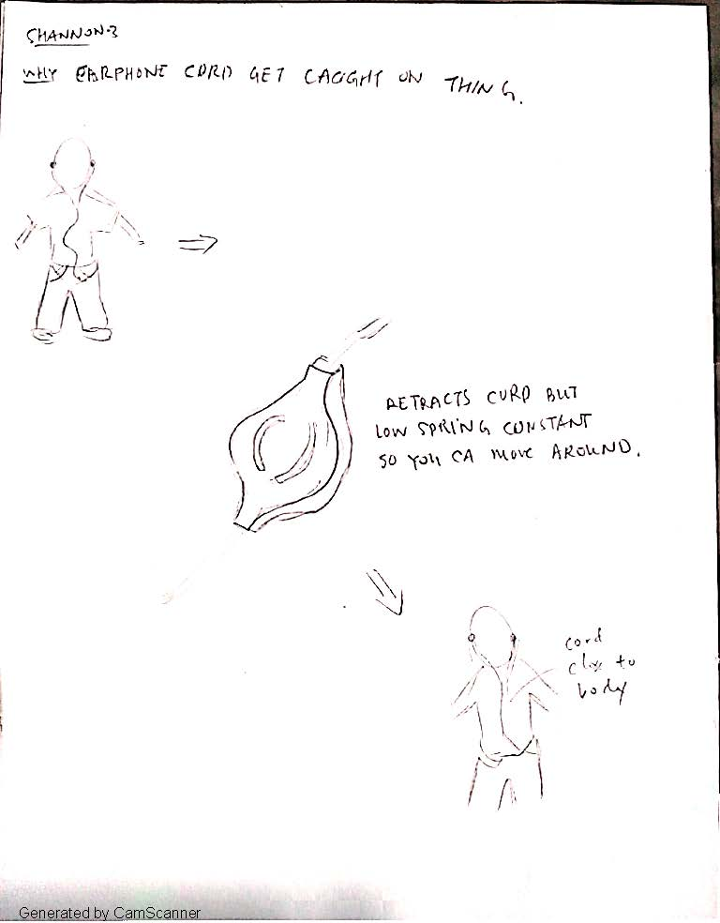

### Design 5

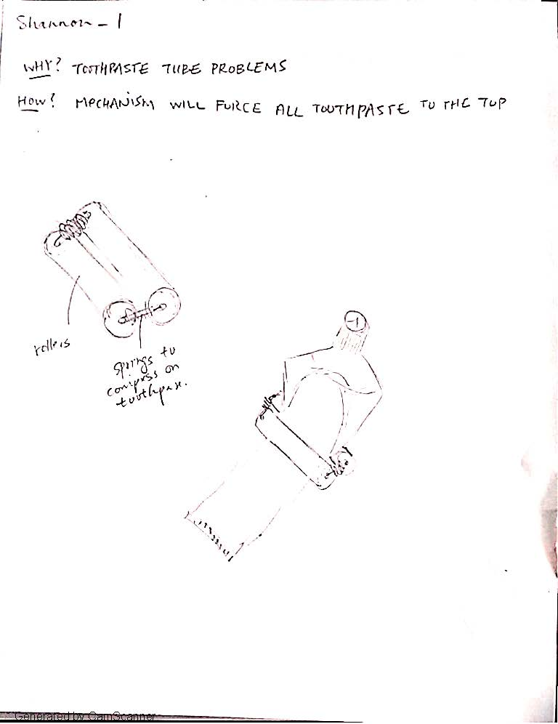

### Design 6

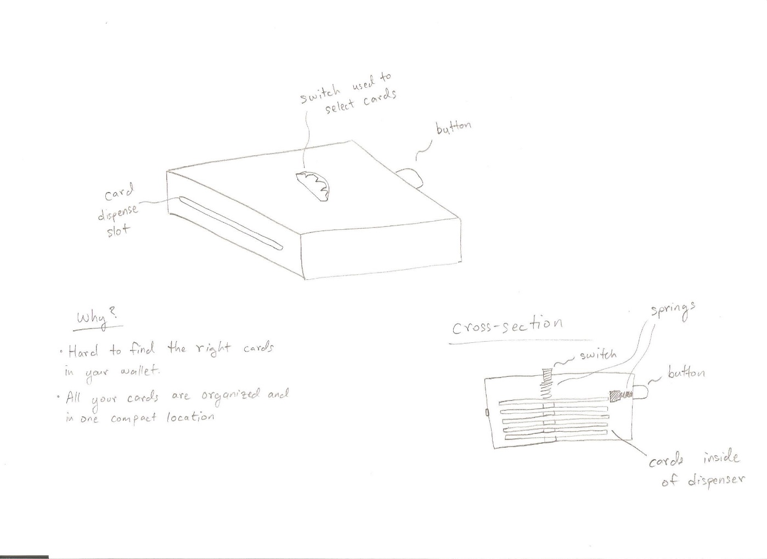

### Design 7

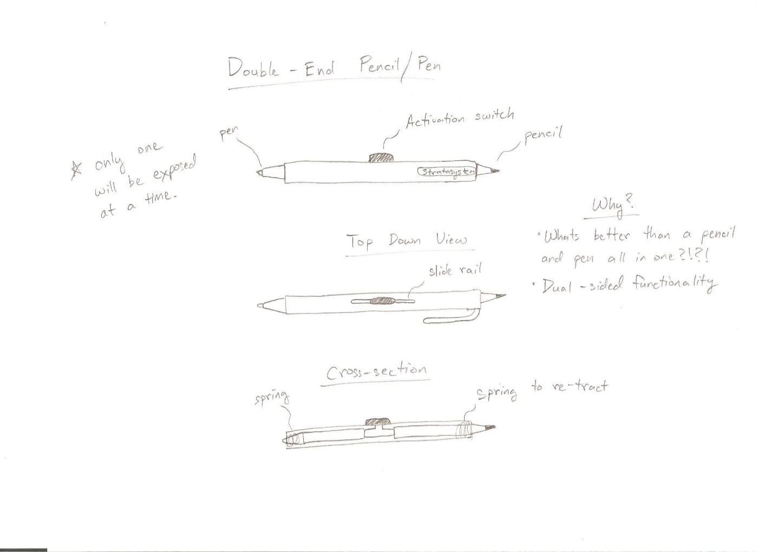

### Design 8

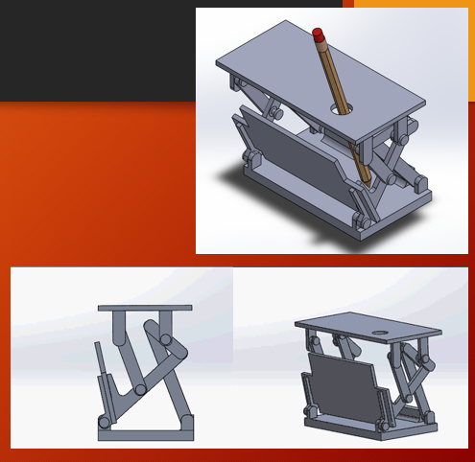

### Design 9

